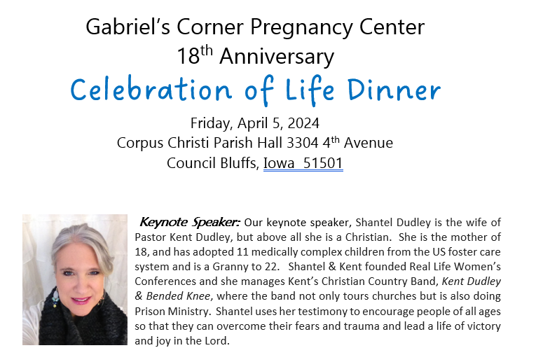

First Name(s):_____________________________________Last Name:____________________________________

Address:_______________________________________________________________________________________

City:_____________________________________State:__________Zip:___________Phone:___________________

I wish to make Dinner Reservations for ______ people at $35 each for a total of $________________

I wish to sponsor a Table of 8 persons for $240 (Please print names on the backside of this card).

I wish to help underwrite this celebration in the amount of $_________________

I wish to make a donation to Gabriel’s Corner in the amount of $________________

I regret that I am unable to attend this event and wish to make a contribution to Gabriel’s Corner in the amount of $______________

Entertainment by Friends of Gabriel’s Corner

You are invited to

Gabriel’s Corner 18th Anniversary
Celebration of Life Dinner

- Wine & Cheese Social begins at 5:30 PM
- Dinner by Celebrate Catering served at 6:30 PM
- Honey Garlic Chicken, Roasted Red Potatoes, Glazed Carrots/Green Beans,
- Dinner Roll and Tossed Salad
- Assorted cupcakes by Debbie Fleming
- Speaker, Shantel Dudley will talk at 7:30 PM

Please Email the Names of Guests at Your Table!

